Castle Semple Sailing Club

www.castlesemplesc.co.uk

Special Operations Manual for
COVID19

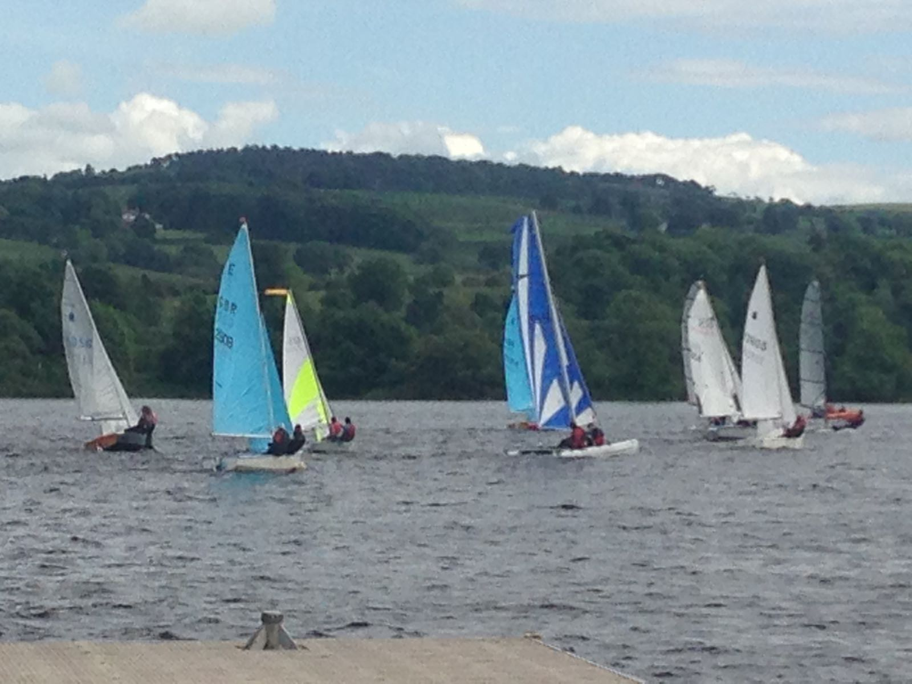

Issue 38- 7/01/2022

Issue and Revision Record

Rev | Date | Description
01 | June 2020 | First Issue
02 | 19/6/2020 | Booking system added. Use of club equipment amended. Misc changes. corrected
03 | 04/7/2020 | Use of club boats and club toilet added.
04 | 15/7/2020 | Updated for Phase 3(15 allowed, updated link, under12 social distance).
05 | 17/7/2020 | Cadet Sailing update, casual racing added and some Phase 3 updates.
06 | 02/8/2020 | Booking link updated.
07 | 22/8/2020 | Number of people allowed at club updated to 25.
08 | 28/8/2020 | Field of play bubbles added.
09 | 11/9/2020 | Update of Committee members/positions.
10 | 13/9/2020 | Booking system details, link & no’s allowed amended.
11 | 12/10/2020 | Field of play bubbles amended. Travel note added.
12 | 23/10/2020 | Face covering information added.
13 | 30/10/2020 | Face covering requirement deleted.
14 | 06/11/2020 | Booking internet address updated.
15 | 22/11/2020 | Details on travel to the club and toilet access updated.
16 | 01/12/2020 | Booking internet address updated.
17 | 04/12/2020 | Details on toilet access, field of play bubbles and committee updated.
18 | 02/01/2021 | Booking internet address updated.
19 | 08/01/2021 | Amendments to no’s allowed at club (and purpose), cadet sailing & field of ofubbles  . internet address updated.
 |  | play bubbles plus update on Gov guidance and misc changes.
20 | 12/01/2021 | Details for booking system updated.
21 | 01/02/2021 | Details for booking system updated.
22 | 19/02/2021 | Details for booking system updated.
23 | 12/03/2021 | Amendment to no allowed at club.
24 | 05/04/2021 | Details for booking system, Gov message, Sailing, Bubbles,
Maintenance updated.
25 | 16/04/2021 | Amendment to Gov message.
26 | 26/04/2021 | Amendment to no allowed at club and sessions per day.
27 | 01/05/2021 | Amendment to booking link.
28 | 01/05/2021 | Amendment to use of club boats.
29 | 01/06/2021 | Amendment to max people allowed, booking of visitors, booking link and
 |  | misc changes.
30 | 01/07/2021 | Amendment to booking link.
31 | 30/07/2021 | Amendment to max people allowed, misc changes.
32 | 06/08/2021 | Amendment to booking link.
33 | 30/08/2021 | Amendment to booking link (for Sept 21 bookings).
34 | 01/10/2021 | Amendment to booking link (for Oct 21 bookings).
35 | 06/11/2021 | Amendment to booking link (for Nov 21 bookings).
36 | 04/12/2021 | Amendment to booking link (Dec 21), risk assessments & who we are. updated.
37 | 17/12/2021 | Sustainability section added.
38 | 07/01/2022 | Amendment to booking link & sustainability section.
List of Contents

CSSC - Who we are

1 Introduction

2 Code of Conduct

3 COVID19 Risk Assessments

4 Sailing

  - Launching and Recovery
  - Responsibilities
  - Accidents

5 Use of Club Sailing Boats

6. Compound

  - Dinghy Storage
  - Compound Access
  - Toilet Access

7. Boat Maintenance

8. Sustainability

CSSC – Who we are.

Castle Semple Sailing Club is a friendly, vibrant club based at Castle Semple Loch, Lochwinnoch, Renfrewshire, only 15 minutes from Glasgow Airport. Our club compound is just past Clyde Muirshiel Regional Park’s Castle Semple Visitor Centre.
New members are welcome no matter their ability.
We have a number of club boats – RS Vision, RS Fevas, Laser Stratos, 505, Lasers, Pico and Toppers and Optimists. These are available for use by members once competence on the water has been demonstrated. (See section 5 Use of Club Sailing Boats).
During the COVID19 pandemic we are operating under special restrictions as detailed in this manual and required by the government and RYA. Only casual sailing is taking place with access to the loch 7 days per week when following the governments travel guidance.
The Club is run by a committee who meet around 8 -10 times a year.

- Commodore/Cadet & Training Officer Peter Collings
- Secretary Colin Dykes
- Treasurer (Bank) Steve Cochrane
- Treasurer (Accounts) Chris Moffat
- Sailing Secretary Angus Winchester
- Membership Secretary/Health & Safety Jules Whitestone
- Property Steward Brian Young
- Cadet/Junior Representatives Andrew Macdonald - Orlagh
- Past Commodore Dawn Kyne

Additionally we have:

Disability contact: Jon Hasler
COVID19 Team: Tom Kelly, Dawn Kyne & Peter Collings
GP14 Contact/Green Credentials: Arthur Logan
Welfare officer: Susie FitzGerald
Club House Project : Mark Simmonds
Boat Maintenance: Alan Falconer
General committee support: Rob McIver

1 Introduction

This Special Operations Manual for COVID19 details the special protocols that have been implemented to allow casual sailing during the COVID19 pandemic crisis at Castle Semple Sailing Club (“CSSC”). There will be no social activities or events.

Where the details in this manual conflict with the standard Operations Manual the details in this manual will take precedence during the COVID19 pandemic.

All members are notified of the existence of this manual and encouraged to read its contents. The highlights of the special protocols will also be communicated by e-mail to the membership and will be re-enforced by signage at the club where required.

Note:
It is still possible to go sailing as a form of exercise but we remind everyone that we are in the grip of a pandemic and any activity should be conservative of risk.
Members are to follow the latest Scottish government guidance with respect to travel to and from the club location.

2 Code of Conduct

It is the policy of CSSC that all members and their visitors/guests show respect and understanding for each other, treat everyone equally within the context of the sport and conduct themselves in a way that reflects the principles of the club. The aim is for all participants to enjoy their sport and to improve performance.

During the COVID19 crisis members will also be expected to

- Refrain from using the club facilities (see exception for toilet as detailed in section 6.3). The club facilities are currently closed and access will only be by a committee member who will follow good hygiene practice.

- Only use a club boat and equipment after being authorised by the committee and booked (see section 5).

- Only use your own personal/private equipment. Do not share equipment or boats unless with someone from the same household (single handed sailing only unless with someone from your own household or in a “field of play” bubble).

- Not bring visitors or guest to the club unless you have booked them in using the club booking system (even if not sailing).

- Only sail when the weather, and expected weather, is within your sailing capability. No safety cover or first aid will be available and sailing will be at your own risk.

- Not to attend the club if classed as vulnerable under the government guidance.

- Not attend the club if suffering from COVID19 or have the symptoms of COVID19.

- Adhere to current government COVID19 guidelines when accessing the club. Particularly following the social distancing, hygiene and travel rules.

If you are concerned that someone is not following the Code of Conduct, you should inform a Club Committee member.

3 COVID 19 Risk Assessments

COVID 19 Risk Assessments have been completed

General COVID 19 Risk Assessment
Use of Clubhouse Toilet Risk Assessment
Provision of Hot & cold Drinks Risk Assessment
Cadet Sailing Risk Assessment

These are reviewed regularly during the crisis. These are on separate documents and the latest versions are available on request.

4 Sailing

At present only sailing which follows the rules and guidance from the RYA will take place. Racing is allowed as long as following the government guidelines for COVID19 and the instructions in this manual.

Sailing should be single handed unless:-

- with a crew from your own household or household bubble.
- when in a “field of play” bubble

A “field of play” bubble can be created for organised sailing activity. The bubble in effect suspends physical distancing guidelines for participants for the duration of the activity.

At CSSC a “field of play” bubble can be created for sailing a dinghy with someone from a different household.

The bubble will consist of the people that will sail the dinghy and will last for the time of the session booked.

You can only be in one bubble in any day.

When you wish to create a bubble this must be recorded on the sheet located in the clubhouse with details of the people in the bubble for track and trace purposes.

Note normal physical distancing guidelines will still apply before and after the activity of sailing in a bubble.

The number of bubbles that can be created is not restricted as long as the number of participants in the session does not exceed the maximum allowed.

The number of people allowed at the compound and on the Loch from the sailing club at any one time is limited to a total of 500 people. To manage this, a booking system has been put in place.
Members wishing to attend the club must book one of the available spaces before coming to the club. Visitors must be booked on the system by a member using the format Members name guest Visitors name e.g. John Smith’s guest Joe Blogs. Under no circumstances should anyone attend without a booking.

Bookings can be made on the internet at the address:-

https://doodle.com/poll/9td53yb3n62drq9m

For clarity, bookings to bubble must be made in addition to booking into the session on the above link. These are recorded on the sheet just inside the clubhouse door. The sheet is similar to that which was used for entering a race.

Cadet sailing will be available and Peter Collings should be contacted for details. During Cadet sailing places must be booked for people attending including non-sailing parents.

There will be no normal club sailing days however club sailing activity for casual sailing will be 7 days per week with 1 session per day.

All club facilities will be closed (see exception for clubhouse toilet in section 6.3).

Only the compound will be accessible to allow access to your sailing boat.

No safety boat or first aid will be available so sailing will be at your own risk. You should only sail when the weather and expected weather is within your sailing capability.

Members should only use their own equipment and arrive at the club ready, as far as possible, to go afloat (no changing facilities will be available).

Members should bring their own refreshments.

4.1 Launching and Recovery

During launch and recovery social distancing must be maintained as per the current government guidelines.

Launching must only take place if the area to be used for the launch is clear and will remain clear during the time needed to complete the launch and stow the launch trolley. Clear means that no social distancing breaches will take place.

Launch trolleys must be stowed in a safe place while you are on the water in your boat.

This means in an area where handling will not be require or take place by any other person.

The pontoon ends should always be left clear during launching to allow returning sailors to use while waiting to recover their boat.

When returning following a sail the area to be used must be clear. If not then a clear pontoon end should be used as a waiting area, if needed, until the required area is clear.

When you have returned and recovered your boat you should return to the compound asap so as not to restrict other water users returning or launching.

Social distancing must be maintained at all times. You should secure your boat following the recovery and leave the club.

4.2 Responsibilities

All participating members, or, in the case of children under the age of 18, their parents, are responsible for their own safety and insurance. It is the individual’s (or parent’s) responsibility to ensure the suitability and condition of their own boat and equipment at all times.

All members will be expected to abide by the decisions of the responsible officers of CSSC with respect to the club and its operation.

CSSC are not responsible for members’ safety whilst on water-borne activities.

All persons involved in on- or off-the-water activities share the responsibility for the safety of the participants.

Therefore:

It is the duty of all members to be vigilant and aware of all circumstances that may

affect the safety of both themselves and others.

It is the duty of all members to notify any committee member of any situation or circumstance that concerns them, or that they feel may affect the safety of any person.

This must be done as soon as possible, and then confirmed in writing if appropriate.

4.3 Accidents

A first aid kit is located in the CSSC club house. Due to the COVID19 crisis and government guidelines access is limited.

If an accident occurs at the club it is the duty of the member to ensure that it is reported to a committee member.

5 Use of Club Sailing Boats

The use of a club boat will only be possible after a request is made and permission is granted from the committee. Permission will be granted only if the member is deemed competent to safely rig and sail the boat and a boat is available for use.

A boat will be allocated on a first come first served basis. The allocation will typically be for one session.

At the end of the allocation period the member should thoroughly clean/disinfected the boat and equipment. Disinfectant will be available at the club for this process. The equipment/boat will then be quarantined for minimum 72 hours before the next use as an additional precaution (unless the boat is allocated again to the same member).

Once permission is given the club boat can be booked on the link:

Book an Appointment with Castle Semple Sailing Club - Events and Entertainment/Club Events

Club boats are only to be used on Sundays and Wednesday evening sessions. Exceptions may be made for Bank Holidays at the committee’s discretion.

The use of the boats will only be for casual sailing at Castle Semple at the users own risk.

It will be the responsibility of the user to check the boat to ensure suitability and water worthiness prior to use. Any issue must be reported immediately to a committee member.

Should any damage or incident occur during the period of allocation the member using

the boat must reported it to a committee member as soon as practical (no later than the day of occurrence). The club reserve the right to charge the user for any uninsured losses.

If the damage is such that the boat is unsafe to sail a notice/warning should be placed
on the boat and only removed once repaired and assessed as safe.

6 Compound

  - Dinghy Storage
Boat storage is provided at Castle Semple Sailing Club for dinghies.

Permission to store a dinghy within the club grounds will only be granted after approval by the property steward.

No boat may be stored at the club without prepayment. Any exception must be authorised by the property steward, Commodore or committee.

Storage charges will be determined by the committee, ratified at the yearly AGM and published in membership renewal documents.

All boats must be fully insured.

The club does not accept any liability for dinghies stored within the club grounds.

Storage is at the member / owner’s own risk.

The club storage compound must be kept locked at all times when not in use.

Safety is paramount and is the responsibility of every member. If suspect practice or equipment is observed, please notify a committee member as soon as possible

6.2 Compound Access

If you are the first to arrive at the club you will be required to open the compound gate. You should immediately wash or sanitise your hands afterwards. You should have your personal sanitiser when visiting the club for this purpose.

The compound gate should be left open during your visit to the club to minimise handling.

Please keep the compound as tidy as possible, and remove any waste materials you create for disposal at home. No bins are available in the compound during the COVID19 crisis.

Lock the compound gate if last to leave the club grounds. You should immediately wash or sanitise your hands afterwards.

6.3 Toilet Access

The use of the club toilet will be possible when following these protocols:

- Only one person at a time in the clubhouse (only to access and use toilet).

- Access to the toilet is only for club members and their visitors.

- No access to changing rooms or the main clubhouse area.

- Contact with surfaces such as walls, doors etc to be avoided as far as possible.

- Members should clean areas of contact before and after use (paper towels and disinfectant will be available in the clubhouse for this task).

- Hand sanatiser will be provided in the club house for use before and after use.

- Please keep the toilet and access area clean and tidy. Waste generated from the cleaning by you will need to be removed for disposal at home (no bins are available). Plastic bags will be available in the clubhouse for this purpose.

Please be respectful of other members and leave the toilet as you would expect to find it.

7 Boat Maintenance

Members are able to access the compound to do maintenance on their boat. They must book a time as if sailing and must follow the clubs Code of Conduct and current government guidelines particularly with respect to social distancing.

Anyone wanting to remove or return their boat to the compound must get permission from the committee first so arrangements can be approved.

8 Sustainability

Castle Semple Sailing Club is committed to minimising the impact of its activities on the environment and to reduce emissions of greenhouse gases with a target to reach net zero.

The club’s aims are:
- To reduce our impact on the environment and our greenhouse gas emissions.

- To encourage all to help us in these aims by their choices.

- To promote relevant local environmental information to participants, such as sensitive habitats and species.

- To prepare sustainability policies for all club activities.

The progress will be reviewed on an annual basis with an update provided at the club AGM.

